Title: DAQ V1.0 Pin Diagrams
Project: Hybrid Sky Data Capture System, Version 1.0
Date: August 26, 2008
Author: Stephen Daniel
1. Introduction
This document contains the pin-outs for all ICs in the V1 implementation of the data capture board. This information is gathered from various data sheets and is used to verify the schematics and PC layout.
The chips are referred to by their part numbers as shown in the schematic.
2. Support Chips
This first section contains all transistors and all ICs except for the microprocessor.
LT1114 Quad Precision Op Amp
This chip is used as U1 through U3 and U5.
Pin | Signal
1 | OUT A
2 | -IN A
3 | +IN A
4 | V+
5 | +IN B
6 | -IN B
7 | OUT B
8 | OUT C
9 | -IN C
10 | +IN C
11 | Ground
12 | +IN D
13 | -IN D
14 | OUT D
LT1167 Precision Differential Amplifier
This chip is U4.
Pin | Signal
1 | Gain resistor
2 | -IN
3 | +IN
4 | Ground
5 | REF
6 | OUT
7 | Vdd
8 | Gain resistor
LT1029A Precision Regulator
This chip is U6 and U7.
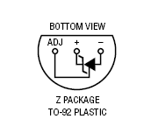
LT1121-3.3 Regulator
This chip is U8.
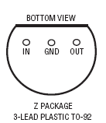
LTC1293 Analog to Digital Converter
This chip is U9.
Pin | Signal
1 | CH 0
2 | CH 1
3 | CH 2
4 | CH 3
5 | CH 4
6 | CH 5
7 | COM
8 | Digital ground
9 | V-
10 | Analog ground
11 | Vref
12 | Din
13 | Dout
14 | CS
15 | CLK
16 | Vcc
LT1121-5 Regulator
This chip is U11.
DS1302 Time of Day
This chip is U12
Pin | Signal
1 | Vcc2 (+5)
2 | Xtal
3 | Xtal
4 | Ground
5 | Chip Select
6 | I/O
7 | CLK
8 | Vcc1 (Capacitor)
H11L1M Schmitt-Trigger Opto-Isolator
This chip is U13 and U14.
Pin | Signal
1 | Input Anode
2 | Input Cathode
3 | NC
4 | Output
5 | Ground
6 | Vcc
2N3904 NPN Amplifier
This is Q1.
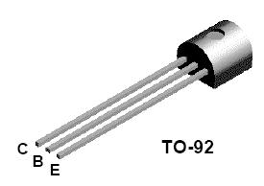
2N3906 PNP Amplifier
This is Q2.
3. PIC Microprocessor
This section contains the PIC pin-out plus some discussion on how the pins were set up.
PIC 18F2455 Microprocessor
This chip is U10.
Pins 1-14 are on the left side of the chip, presumed to face towards the analog side of the board. Pins 28-15 are on the right side of the chip and are used for digital functions.

PIC Pin | Signal Name | External Pin | Function
1 | MCLR |  | Wired to an "execute mode" push button (inverted)
2 | RA0 |  | Input from mode select switch
3 | RA1 |  | Record/stop switch
4 | RA2 |  | Output to red LED
5 | RA3 |  | Output to green LED
6 | RA4 |  | Raw pin0 to outside world
7 | RA5 | ADC 15 | Clock to A/D
8 | VSS |  | VSS
9 | OSC2 |  | Crystal
10 | OCS2 |  | Crystal
11 | RC0 | ADC 14 | Chip select to A/D
12 | RC1 | ADC 13 | Data from A/D
13 | RC2 | ADC 12 | Data to A/D
14 | Vusb |  | .022 uf cap

PIC Pin | Signal Name | External Pin | Function
28 | RB7 |  | Opto-isolated digital input 1
27 | RB6 |  | Opto-isolated digital input 0
26 | RB5 |  | Raw pin to outside world 1
25 | RB4 | TOD 5 | Chip select to TOD chip
24 | RB3 | TOD 6 | Data to/from DS1302 TOD chip
23 | RB2 | TOD 7 | Clock to TOD chip
22 | SCK | SD 5 | Clock to SD memory card
21 | SDI | SD 7 | Data from SD
20 | VDD |  | VDD (5 volts)
19 | VSS |  | VSS
18 | SDO | SD 2 | Data to SD
17 | RC6 | SD 1 | Chip select to SD
16 | D+ |  | Data to/from USB
15 | D- |  | Data to/from USB

External Connections
MCLR MCLR is an inverted signal. Should be held high, pushing button brings it to logic 0.
RA0 Mode select switch is a rotory switch with multiple positions. The switch is wired with 10K resistors to act like a crude potentiometer between VSS and VDD. Center tap comes out to the PIC pin.
RA1 Record/Stop switch is SPST. In "stop" mode the switch is open and the signal is logic 0 (pulled down through a 10K resistor). In record mode the switch is closed, and the signal is logic 1.
RA2,3 The LEDs are directly driven from the PIC, which provides 5 volts at up to 25 milliamps.
RA4, RB5 Raw pins come out to a screw terminal. The terminal should be a pair, pin and ground. If the pin is not in use then a wire should connect the pin to ground.
4. External Connectors
Most of the external connectors are simple screw terminals. However there are two connectors that are more complex whose pin-outs are provided here.
SD Memory Card Connector
This chip is connector SD1.

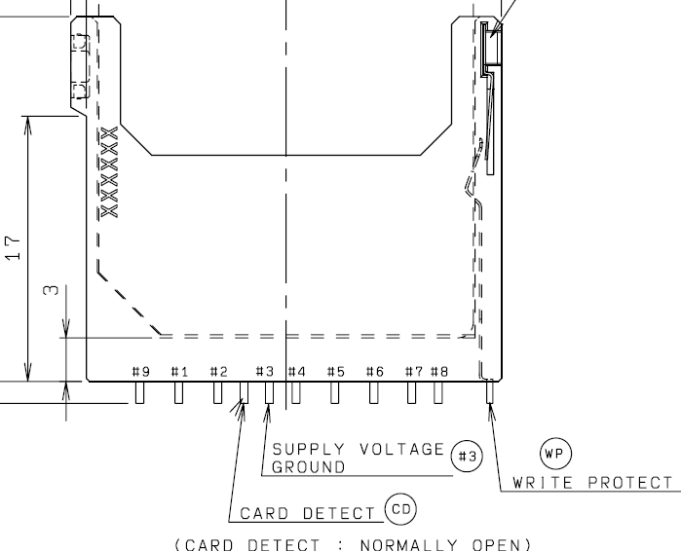

Pin | Signal
1 | Chip Select
2 | Data In (to SD card)
3 | Ground
4 | VDD
5 | CLK
6 | Ground
7 | Data Out
8 | Not used
9 | Not used
USB Type B Connector
This chip is connector USB1.
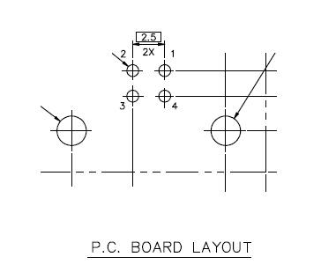
This is shown with the USB receptacle pointing down.
Pin | Signal
1 | VBUS
2 | D-
3 | D+
4 | Ground

